**Assignment -2**

Digital Marketing

|  |  |
| --- | --- |
| Student Name | Kali Sangareshwari M |
| Student Roll Number | 20URCS019 |
| NM ID | 2CACCF0CD5ECD7581324C8C06D826450 |
| College Name | AAA College of Engineering and Technology |

**QUESTION:**

**Create a New Facebook Business Page and post one social media poster for your brand.**

**FACEBOOK BUSINESS PAGE :**

**Page link:** <https://www.facebook.com/profile.php?id=61550624845695>

**Title: Royal Wrists**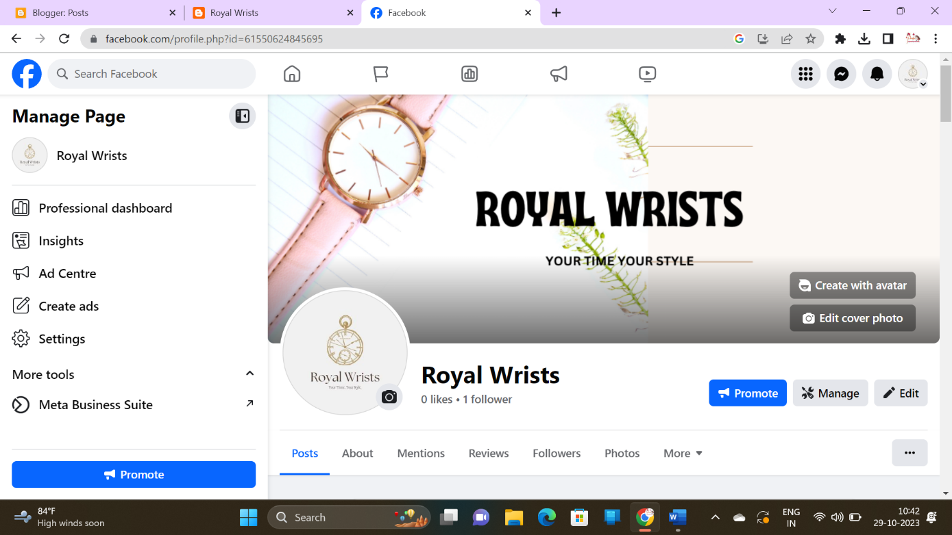

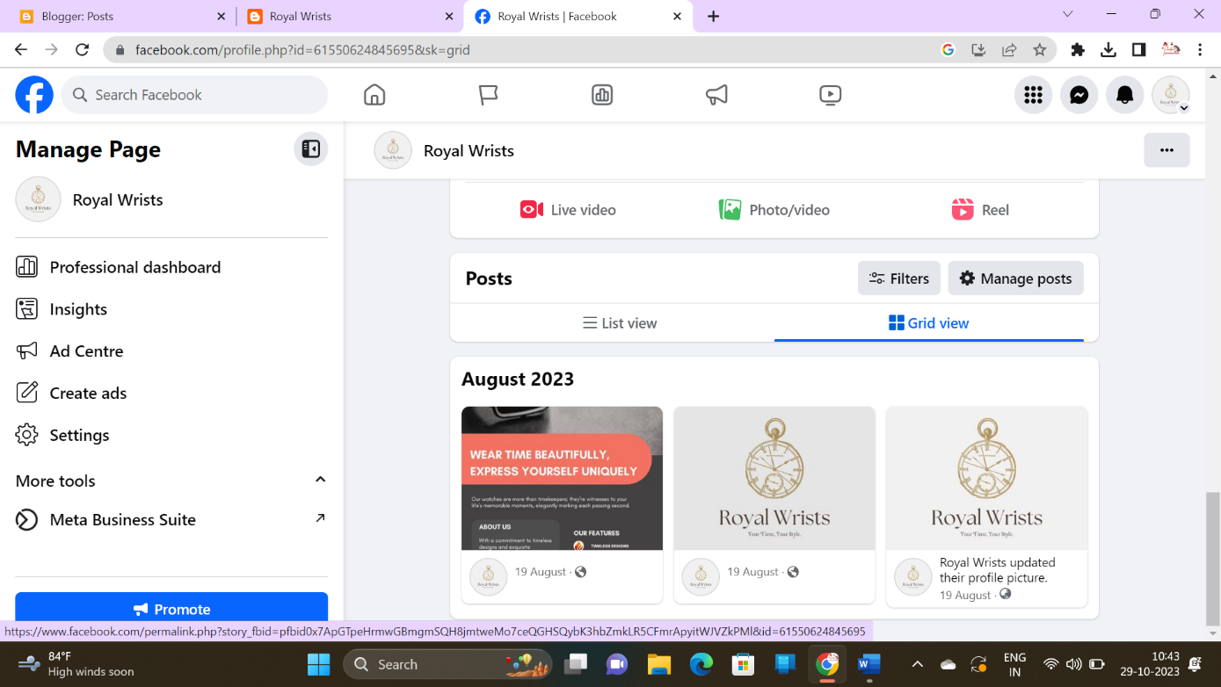

**SOCIAL MEDIA POSTERS :**

